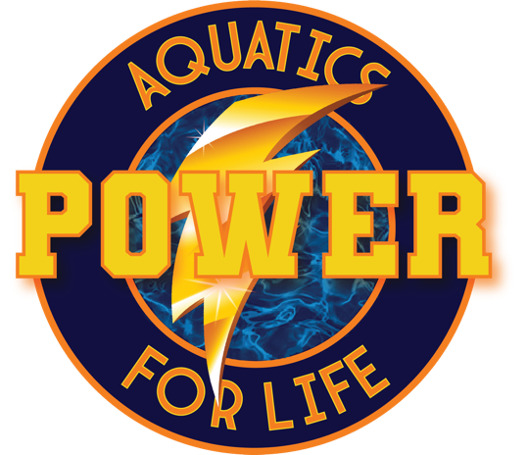
2025 Fleet Summer Classic- May 16-18th
I want to thank everyone that came out and represented Power for Life Aquatics. The first step to being a competitive team is showing up to meets consistently. We had 3 athletes that represented us on Friday, and I would like to give them some props. Luke Bruno, Nico Alvarez and our only 12 and under Logan Loc. I would like to shout out to Chris Tower for being an official for our team at the meet and finally our parents for getting the kids to the meet, dealing with the heat and timing for our team. These meets are fun for the kids, especially when their friends show up. It builds relationships that last a lifetime.
Below is a list of our athletes that were able to show up and race for Power for Life. Way to step up Gang!!!!!
Nico Alvarez, Stratton Arnold, Micah Boldt, Luke Bruno, Reed Cheadle, Yamid Cifuentes, David Conde-Dobocan, Makayla Cruz, Sophia Cruz, John Foreman, Alex Gilson, Seth Grayson, Hailey Ho, Braeden Hoxworth, Reese John, Sophia Laver, Alejandro Leonardi, Rebecca Li, Asher Lin, Logan Loc, Flynn Michielsen, Luana Milne, Hunter Nguyen, Zoey Nguyen, Regan Olson, Grace Rhode, Grayson Ruppert, James Shoup, Isabelle Simons, Tres Simpson, Milo Tower, Erin Trichkovikj, Sydney Troutman, Camilla Turcios, Ezequiel Turcios
This meet was a long course meet which means it was a 50 meter pool (Olympics are in a 50 meter pool). Many of our athletes have not done many, if any, meets in long course meters. The meet host converted the yards times to meters for their entry times. The conversion is challenging due to the fact that long meters is a LOT harder to do than short course yards. If our athlete have not done the event in meters, I counted it as a NT or no time for the results. Once they have a long course time, we can start to get better from there. Below is how we did. Please remember that the only bad swim is a swim that you don’t learn from. Mistakes are part of how we learn and get better.

Athlete Swims/ Best times
Nico Alvarez 4/4
Stratton Arnold 5/6
Micah Boldt 6/6
Luke Bruno 2/7
Reed Cheadle 3/3
Yamid Cifuentes 5/6
David Conde-Dobocan 3/3
Makayla Cruz 3/3
Sophia Cruz 3/3
John Foreman 3/3
Alex Gilson 1/6
Seth Grayson 5/6
Hailey Ho 5/6
Braeden Hoxworth 2/6
Reese John 6/6
Sophia Laver 5/6
Alejandro Leonardi 3/3
Rebecca Li 3/3
Asher Lin 0/3
Logan Loc 6/6
Flynn Michielsen 3/3
Luana Milne 5/6
Hunter Nguyen 1/1
Zoey Nguyen 3/3
Regan Olson 0/3
Grace Rhode 1/2
Grayson Ruppert 5/5
James Shoup 3/3
Isabelle Simons 6/6
Tres Simpson 5/6
Milo Tower 4/6
Erin Trichkovikj 3/6
Sydney Troutman 2/3
Camilla Turcios 3/3
Ezequiel Turcios 3/3

Our next meet will be June 27th-29th. Please try and plan to attend if you’re in town. Racing is a skill that can only be developed by going to meets. If this is going to be your athlete’s sport of choice, let’s help them reach their potential by attending swim meets. Look for the sign up to come out soon.
Once again thank you for being a part of Power for Life Aquatics. WE couldn’t do this without you.
Take care,
Power for Life Aquatics Staff

